**VBA -Challenge: Stock Market Analysis**

**Instructions**

* Create a script that will loop through all the stocks for one year and output the following information.
  + The ticker symbol.
  + Yearly change from opening price at the beginning of a given year to the closing price at the end of that year.
  + The percent change from opening price at the beginning of a given year to the closing price at the end of that year.
  + The total stock volume of the stock.
* You should also have conditional formatting that will highlight positive change in green and negative change in red.
* The result should look as follows.

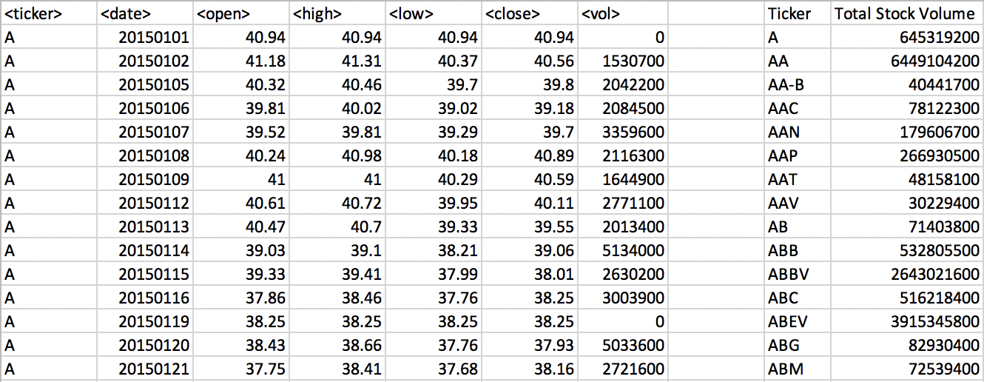

### CHALLENGES

1. Your solution will also be able to return the stock with the "Greatest % increase", "Greatest % decrease" and "Greatest total volume". The solution will look as follows:

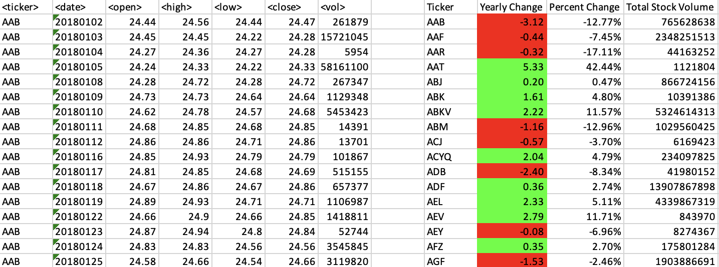

Add functionality to your script to return the stock with the "Greatest % increase", "Greatest % decrease", and "Greatest total volume". The solution should match the following image:

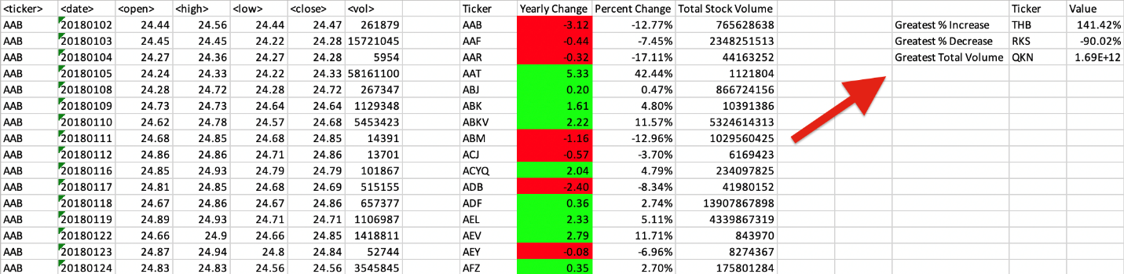

In this Module Challenge I was effectively able to use VBA to complete the challenge instructions given. Further in-depth detail can be found in the Gitlab Portal to show how I derived to the same conclusions as the examples provided.

I was able to initiate loops for multiple worksheets in a Workbook, declare variables, create a Sub & end Sub create dimensions, create IF and ElseIF statements all while usings ranges, cells & functions to generate the conclusions requested I also learned how to set and create column & row names.

References

Data for this dataset was generated by edX Boot Camps LLC, and is intended for educational purposes only.

Copyright

© 2024 edX Boot Camps LLC